**Proposal**

**For**

**School Management System software**

**Prepared For**

**Trust Technical Training Institute (TTTI)**



**Submitted By**



**KitePlex IT LIMITED**

868,Shawrapare, Mirpur,

Dhaka-1216, Bangladesh

Phone: +88 02 9007364

Web: www.kiteplexit.com

(This offer is being submitted to the above client by KitePlex IT Limited, on the understanding that the contents of this document will not be divulged to any third party without the express written consent of KitePlex IT Limited. It is also understood that KitePlex IT Limited will not divulge any confidential information about this client that it may have access to in the course of executing the project described in this document)

**Ref**: kpit/2014/1116/V-1 **Date:** November 16, 2014

To

The Principal

Trust Technical Training Institute (TTTI)

Gazipur

**Subject:** **Technical & Financial proposal for deployment of School Management Solution (SMS).**

Dear Sir,

We, KitePlex IT Ltd., are happy to submit the technical & financial offer to deploy the software School Management Solution (SMS) for your esteemed instituted. We state features and technical as well as financial issues of SMS for your kind consideration.

If your honor, fever us providing with the opportunity to deploy the software. We shall try our best to complete the project within the given time frame.

Look forward to work with you in near future.

Yours faithfully,

**Mohammad Shakawat Hossain**

Director, Business Development

KitePlex IT Ltd.

868, Shawrapara, Mirpur, Dhaka-1216

Phone: +88-02-9007364

Cell: 01711262567

Email: shakawat@kiteplexit.com

**Confidentiality Agreement**

Trust Technical Training Institute (TTTI), referred in this document as TTTI agrees that the information in this document shall not be disclosed outside TTTI and shall not be duplicated or used in whole or in part for any purpose other than to evaluate this document.

We, referred as consultant and software developer, are eager to discuss any aspect of this document or other services that may be needed by TTTI to support their information requirements. Any issues or queries arising should be addressed to:

**Mohammad Shakawat Hossain**

Director, Business Development

KitePlex IT Ltd.

868, Shawrapara, Mirpur, Dhaka-1216

Phone: +88-02-9007364

Cell: 01711262567

Email: shakawat@kiteplexit.com

**Understanding of the Assignment:**

Trust Technical Training Institute plans to implement software named School Management System (SMS). This is require Web Server, Database Server and improving local LAN.

|  |  |
| --- | --- |
| Company Profile  **Introduction**  KitePlex IT Ltd is a Bangladeshi limited Software development and IT service company incorporated under company act 1994. KPIT is a collection of young entrepreneurs and full of innovative ideas. KitePlex IT Ltd an innovation driven Software Development company that places high value on collaborative interactions, rapid development delivery of solutions, and prioritizing the needs of its customers.  **A collaborative approach**  In concert with prospective customers and partners, KitePlex IT Ltd takes a highly collaborative approach to business relationships. We're good listeners, value feedback, and believe in working together. KitePlex IT Ltd is committed to providing customers with world-class solutions, service, and support throughout relationship.  **Vision**  Our vision is simple.  -          Train and prepare knowledge workers for the industry  -          Research through innovation to adopt technology  -          Develop solution with quality of work  -          Help others sharing our experiences  **Business Domain**  Our business domain is diverse. We take a challenge to develop a sustainable business model through innovation and new ideas collaborating with the other businesses or simply defining solutions to the problem specific.  Four sectors we define to work on:   * Training * Research * Consultancy * Software Development   Through training we will meet the issues of lack of highly availability of knowledge workers or simply upgrading their skills to meet our and industry needs and demands. It insures the inflow of the resources.  By insuring the inflow of young and fresh resources we will never be in short of fresh ideas for research and development. R&D insures the quality of our products lineup and services.  We have the skill set and experiences to offer consultation to any industries that needs automation or rendering IT-oriented services.  **Team**   1. Managing Director 2. Head of Research and Technology 3. Project Manager 4. Programme Coordinator 5. Sales and Marketing Manager 6. Senior Software Engineer 7. Software Engineer 8. Support and Service Assistant   **Client List**   1. EERT ltd. 2. A2I 3. Bangladesh Government 4. Apollo Hospital |  |

**School Management Solution**

School Management is relatively new in Bangladesh. In this form of solution institute identify or track any student any time. SMS is a complete web based application. The system needs only be installed on the server placing minimal requirements on the end user workstation. This makes maintaining and updating the system much simpler as usually it can all be done on the server. Any user updates can be deployed via the web server with relative ease.

**What SMS do for your business?**

* Smooth management and tracking of service request status
* Determine the effectiveness of marketing, industry segments or pretty much anything else
* Integrate into your existing workflow
* Save man-hour and reduce administration costs
* Gain customer satisfaction through quick service
* Management time savings through single window monitoring
* Administrative time savings through performance reports
* Increases visibility and transparency

**User Interface (UI) Management Module**

In SMS user interface (UI) can be managed, which help user to setup the menu/links as per his requirement.

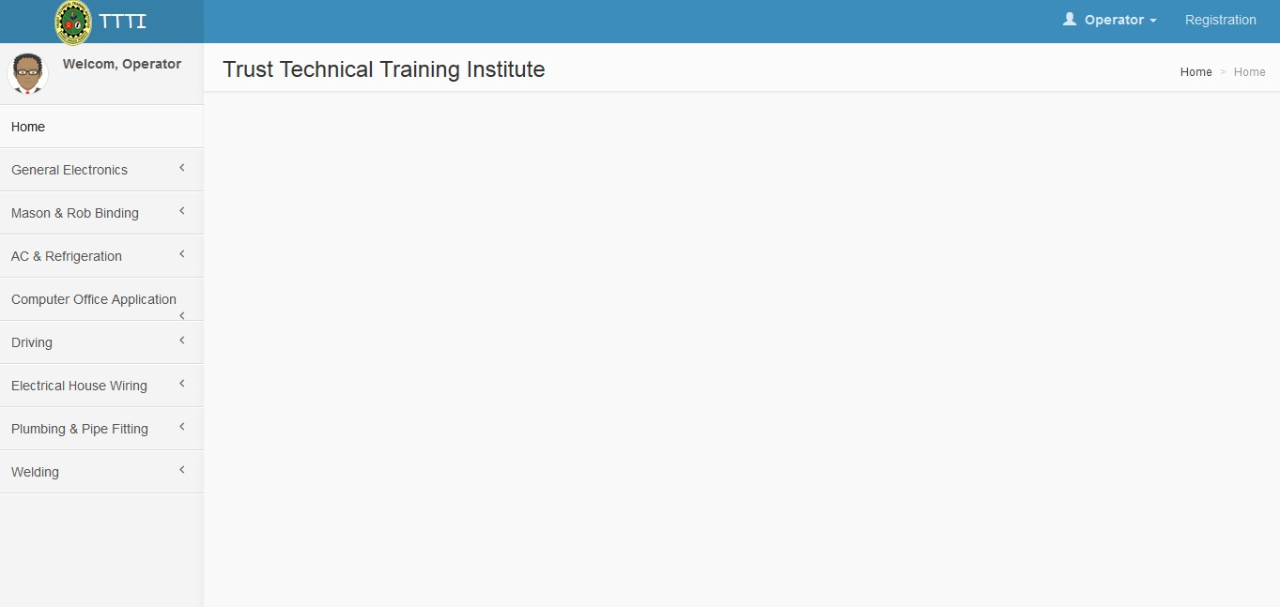

**Student Registration and Database Management**

To get the facility of student need to be registered for this service. SMS will manage student registration process.

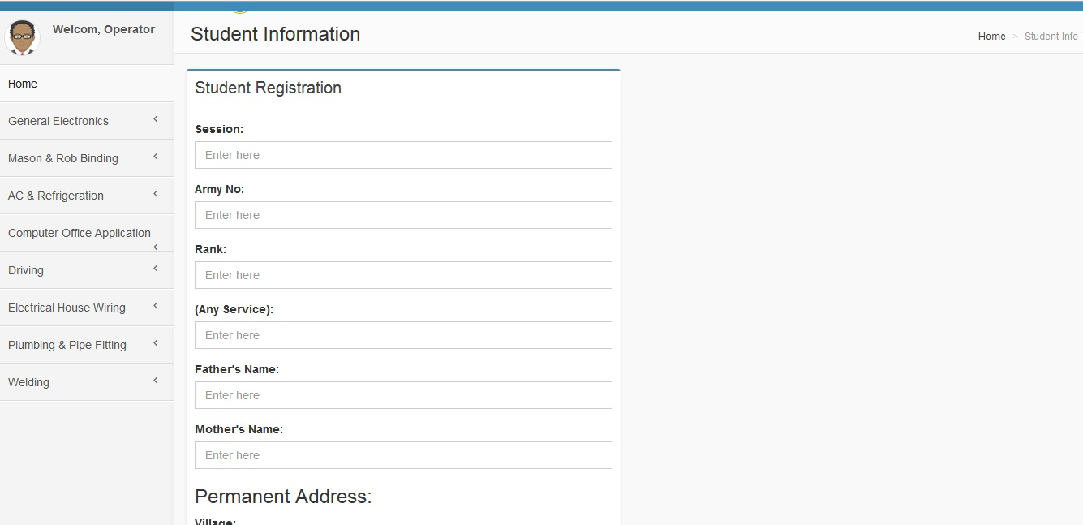

**System Generated ID Card**

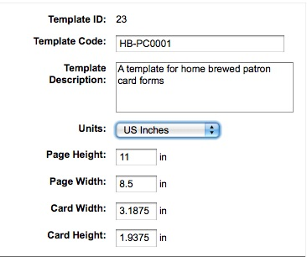

**Student Database Management**

Each student have separate Id that contains details required information of the customer. Customer information can be entered into SMS in 3 different ways:

* By Entry Form
* By uploading from files
* By Integrating with Core system

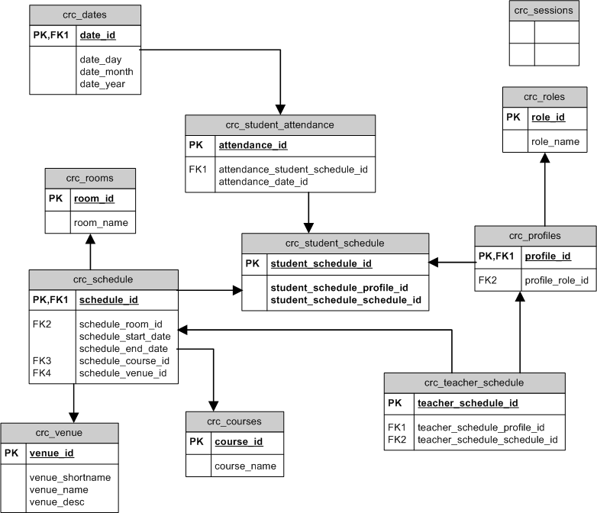

**Successful Student Placement Details:**

SMS will have the facility to manage the database of various professional organizations, which will be used to maintain the student placement details. There will be option to maintain the multiple records of student with various professional organizations.

**Dashboard**

The goal of the dashboard is to automatically show user useful information and other objects

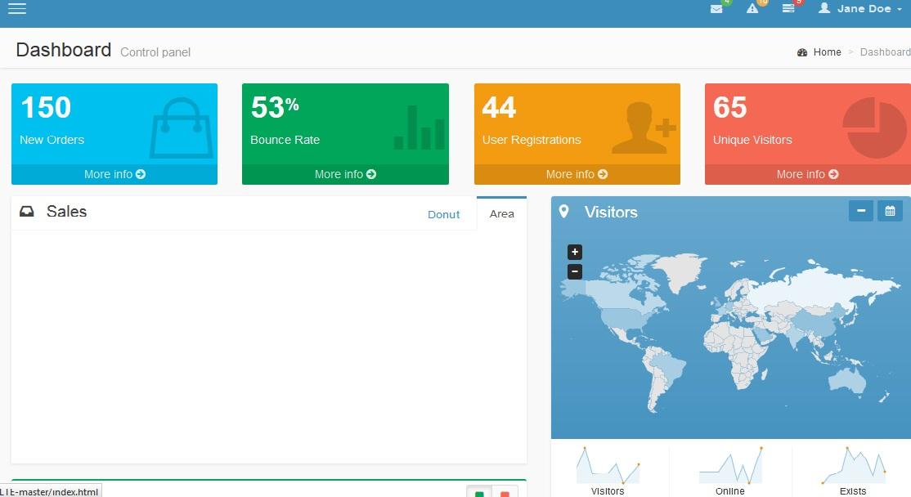

**News & Events**

SMS will have its own News and Events section for the students

**Reports**

SMS has an extensive reporting module. It has also the option to customize the report from user interface.

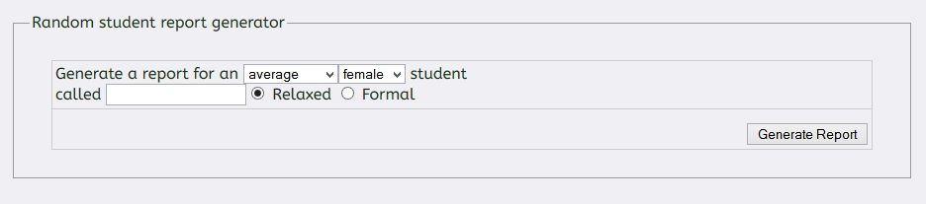

**Technology Used**

|  |  |
| --- | --- |
| **Framework** | C:\Users\Masud\Desktop\grails.jpg Grails |
| **Programming Language** | **C:\Users\Masud\Desktop\groovy.pngGroovy,C:\Users\Masud\Desktop\java.jpg Java** |
| **Database** | **C:\Users\Masud\Desktop\mysql.png** |
| **Web Application Server** | C:\Users\Masud\Desktop\tomcat.jpg |
| **Server OS** | C:\Users\Masud\Desktop\inux.jpg |

**Hardware & Software Requirements**

**Hardware requirements:** Web Server and Database Server.

The requirements in the following table apply both to installations on a single server with a built-in database:

|  |  |  |  |
| --- | --- | --- | --- |
|  |  |  |  |
| **Component** |  | **Minimum requirement** |  |
|  |  |  |  |
| Processor |  | Quad Core Intel Xeon Processor 2.53 GHz or Higher |  |
|  |  |  |  |
| RAM |  | 4 GB (minimum) |  |
|  |  | 16 GB (Recommended) |  |
|  |  |  |  |
| Hard Disk |  | 500 GB (minimum) |  |
|  |  | 1 TB (Recommended) |  |
|  |  | For production use, you need additional free disk space for day-to-day operations. |  |
|  |  |  |  |

**Software requirements:** SMS requires a web server environment and will run in Apache easily. SMSwill run in any server environment that supports Java and use MySQL as a database.

|  |  |  |  |
| --- | --- | --- | --- |
|  |  |  |  |
| **Component** |  | **Requirement** |  |
|  |  |  |  |
| Operating System |  | Linux |  |
|  |  |  |  |
| Web Server |  | Apache Tomcat |  |
|  |  |  |  |
| Platform |  | Grails 2, Groovy, Java |  |
|  |  |  |  |
| Database Server |  | MySQL 5.5 |  |
|  |  |  |  |

**Client Responsibilities**

1. Provide KitePlex IT Ltd. Analysts/Designers/Programmers access to information pertaining to the existing business process.
2. Assign a single point of contact for maintaining communication with KitePlex IT.
3. Provide all the contents (image, video, text etc.)
4. Feedback by client, if any, on any documents/software submitted by KitePlex IT to client for approval or sign-off, should be communicated in writing within two (2) working days (or the time mentioned when submitting the documents). Any delay shall equivalent impact on the project schedule.
5. Provide classroom equipped with multimedia projector, computers and necessary software for user training on the application.
6. Nominate personnel for training as per the schedule of training drawn up with mutual agreement.

**KitePlex IT Responsibilities**

1. To appoint a Project Manager and deploy a team of professional, as required, to undertake the activities related to the execution of the project.
2. To perform the activities, as per our scope of work, adhering to the time schedule specified.
3. To ensure availability of hardware, system software, database and front-end development tools at KitePlex’s development center for smooth execution of the project.
4. KitePlex will not responsible for any server configuration, hardware failure or any other technical issue rather than software/website development.

**Join Responsibilities**

1. Nominate a Project Manager who will be the single point of contact on all aspects of this project.
2. Ensure availability of appropriate personnel for discussion with KitePlex project team during various stages of the project. Non-availability of such personnel, or delay in their availability, will lead to proportional delay in project completion.
3. Ensure Weekly management review of the project where project manager from both KitePlex and client will be present to iron out problems, if any, speedily.

**General Terms & Conditions**

1. Offer is valid for 30 days.
2. Work order should be written and formal. Unless otherwise mentioned in order, it is implied that all our terms and conditions including payment terms are accepted.
3. Work order is not cancelable.
4. TTTI will use the software only in its own business, and not directly or indirectly for the use or benefit of anyone other than TTTI.
5. No software components or design elements developed or provided by KitePlex may be copied, replicated, shared, re-used, reproduced, decode, alter, decompile, reverse engineer, perform reverse analysis on or disasseTTTIe in any format without prior written consent.
6. Although the functionalities/reports are stated at scope of work under different functionality/report heads, one functionality/report may fulfill/cover up multiple functionalities/reports.
7. The ownership of the source code of the system will be preserved by KitePlex. However, in case of liquidation of KitePlex or any situation that KitePlex failed to continue the service, TTTI may intend to purchase the source code. In that case KitePlex will be obliged to sale it in a negotiated price.
8. KitePlex will not provide software or licensing for software that is required for SMS. TTTI will provide all software and licensing for software that is specific to SMS.
9. Standard Support is available from 10:00 AM to 04:00 PM, Sunday- Thursday.
10. Response time to support service - KitePlex will ensure that the support team will answer query as soon as possible but cannot guarantee that TTTI will not experience some delay as a result of factors including, but not limited to, call volume variations and system downtimes. KitePlex offers a 6 hour response time which means that as a general rule KitePlex will respond to TTTI’s call within 6 hours from when TTTI call the Help Desk (provided calls are made during Support Hours).
11. After Hours Emergency Support - If TTTI call outside of support hours and if it is an emergency, there will be emergency telephone numbers available to TTTI. Access to after hours support is strictly limited to “Critical” situations.
12. KitePlex will provide software services to customer only by communication with the customer’s designated technical contact or contacts. TTTI authority agrees to log each support issue by email to KitePlex.
13. TTTI will agree KitePlex is not liable for any failure to carry out services for reasons beyond it's control including but not limited to natural disaster, network or internet problems, web server failure, database server failure, hardware failure, third party interference, Government, emergency on major scale or any social disturbance of extreme nature such as industrial strike, riot, terrorism and war or any act or omission of any third party services.
14. TTTI will agree KitePlex is not liable for absence of service as a result of illness or holiday.
15. Software solutions provided by KitePlex may only be installed at the stated location.
16. Additional work requested by TTTI authority which is not specified in the stated work volume is subject to a separate work volume and KitePlex reserves the right whether to quote or accept additional work. If additional work is accepted by KitePlex may affect timescale and overall delivery time of the project. And addition of any additional work will be charged accordingly.
17. The duration of the maintenance contract should be software life time.
18. The maintenance service will include the following:
    1. Root-cause analysis - Analysis of the root causes of problems. Problems will be reviewed to determine their root causes, measures will be taken to correct the sources of the problems, and reports will be prepared and distributed in a timely fashion.
    2. Bug fixes - Defined as the emergency repair of any system operation that does not comply with the current signed and approved system specification. This includes system errors, "hung" or halted screens, or unexpected results within the system that render it unusable for the purpose for which it was designed.
    3. If any existing functionality doesn’t work properly will be corrected.
    4. Calculation related errors will be corrected.
    5. Minor design related changes will be corrected.
    6. Scripting related problems will be corrected.
    7. Database related problem will be corrected.
    8. Minor changes in the existing report format, limited to add/subtract columns if column value or data exists in the system.
    9. 2 calls per month.

The maintenance service will not include:

1. Any addition of page/form.
2. Any addition of new functionality.
3. Any extension of existing functionality.
4. Any addition of new reports.
5. Changes in the existing report – new calculation, column generated from new input value, etc.
6. Raw data entry.
7. Backup of database.
8. Adaptive maintenance **-** Defined as activities relating to upgrades or conversions to SMS due to new versions of operating environment, including operating system, application server, or database software.
9. More than 2 calls per month. Additional call will be charged an amount of TK. 5,000.00 (Taka Five Thousand Only) per call.
10. KitePlex’s support managers are not required to be on call. If at a later date TTTI requires the support managers to be on call for a specific purpose, or on a longer-term basis, then the KitePlex support managers will be compensated at the standard on-call rate for support staff, and TTTI shall be charged for this service.
11. To install the software package outside the Dhaka city, TTTI authority will agree to bear the cost of transportation and accommodation.
12. For training session outside the Dhaka city, TTTI authority will agree to bear the cost of transportation and accommodation.
13. At the end of each payment methodology phase, KitePlex will submit the bill and TTTI will agree to disburse the bill within seven (7) banking days.
14. Any payment made by TTTI to KitePlex will not be returnable under any circumstance.
15. TTTI will not directly or indirectly solicit or offer employment to or hire any employee or former employee of KitePlex.
16. KitePlex reserve the right to link to, refer to or use as examples any work undertaken on behalf of TTTI for marketing purposes.
17. KitePlex Services reserves the right to re-use, re-engineer or re-distribute either in part or whole at its own discretion, code, code modules, designs or other components which may have been developed on behalf of TTTI.
18. Any time or date stated for intended delivery is given as an estimate only and shall not be of the essence.
19. Signature of any delivery note by an agent, employee or representative of TTTI shall be deemed conclusive proof of delivery.
20. TTTI shall not be entitled to make any deduction from the price of the software in respect of any set-off or counter claim unless both the validity and the amount thereof have been expressly admitted by the company in writing.
21. In the event of any delay KitePlex shall not be under any liability whatsoever to TTTI. The expression ‘liability whatsoever' in these conditions shall mean all liability of any kind including, without prejudice to the generality of the foregoing, liability in contract for negligence or under statute.
22. The placing of an order shall be deemed to be subject to these terms and conditions. Any other provisions contained in any document issued by TTTI shall be excluded from these terms and conditions.
23. The copyright of the delivered system will be preserved by KitePlex IT Ltd. under the copyright law in practice. TTTI shall not sale, distribute, or make illegal copy of the software, documentation or any portion of those.
24. No modification or amendment of these terms and conditions shall be binding upon KitePlex unless otherwise stipulated herein or agreed to in writing by a Director of KitePlex.
25. The above mentioned terms and conditions may be subject to change, continued use of our software constitutes acceptance of these terms, and it is client’s responsibility to ensure that they check these conditions on a regular basis.

**Financial proposal**



**KitePlex IT LIMITED**

868,Shawrapare, Mirpur,

Dhaka-1216, Bangladesh

Phone: +88 02 9007364

Web: www.kiteplexit.com

**Ref:** kpit/2014/1116/V-1 **Date:** November 16, 2014

**Financial Proposal**

**For**

**TTTI**

***School Management System (SMS) Software, additional H/W and Related Services***

|  |  |  |  |
| --- | --- | --- | --- |
| **Sl No** | **Item** | **Onetime Cost** | **Maintenance Cost** |
| **1** | **Software Price** | **200,000** | **3,000\*\*** |
| **2** | **Web Server Hosting** | **30,000** | **10,000\*\*\*** |
| **3** | **Database Server** | **300,000** | **50,000\*\*\*\*** |
| **4** | **Local LAN** | **150,000** | **Maintain by TTTI own** |
| **5** | **Internet Connectivity** | **30,000** | **15,000\*** |

**Prices are exclusive of VAT & Taxes.**

**\*Monthly**

**\*\*Monthly but first six month free**

**\*\*\*Yearly**

**\*\*\*\*Yearly but after warranty 2years**

**Terms and Conditions**

1. This offer will remain valid for a period of 30 days.

2. Serial number 1 is our deliverable. Rest of Serial number will manage by TTTI own. We can help you in this regards.

3. 50% of total amount of Software will pay with Work Order as advance and rest of amount will pay after final delivery.

Thanking you

___________________________

**Mohammad Shakawat Hossain**

Director, Business Development

KitePlex IT Ltd.

868, Shawrapara, Mirpur, Dhaka-1216

Phone: +88-02-9007364

Cell: 01711262567

Email: shakawat@kiteplexit.com